## A poster with a plant in a pot Description automatically generatedBackground

**How to show your support for Mental Health Week**

*Mental Health Week in Tasmania is coordinated by the Mental Health Council of Tasmania*

**Social Media Kit**

The Mental Health Council of Tasmania is the coordinating organisation of Mental Health Week in 2024, which is supported by the Tasmanian Government. The theme for Mental Health Week is **‘Appreciate the little things’**.

**Mental Health Week in Tasmania will take place 5 – 13 October 2024.**

## What is Mental Health Week in Tasmania?

Mental Health Week is part of a national mental health promotion campaign held in October each year, and incorporates World Mental Health Day, held globally on 10 October. The purpose of this awareness week is to engage communities in activities that promote mental health and wellbeing and also increase understanding and reduce stigma about mental illness, and how it impacts on the lives of people in our community.

## How to show your support

**Host your own MHW event.** [Register](https://mhct.org/mentalhealthweek/registeranevent/) your MHW event or activity on our online program. We also have an [Event Planning Kit](https://mhct.org/wp-content/uploads/2024/06/MHW-2024-Event-Planning-Guide.docx) to help you plan and run a successful activity.

**Explore the events and activities happening during MHW and get involved**. There are heaps of fun, family friendly events happening around the state. [Check the program](https://mhct.org/mentalhealthweek/program/) to find what’s happening near you.

**Spread the word!** You can download social media tiles, email banners, Zoom/Teams background and other resources [on our website, here](https://mhct.org/mentalhealthweek/resources/). We’ve also created some suggested social media and newsletter copy down below to go along with them, below.

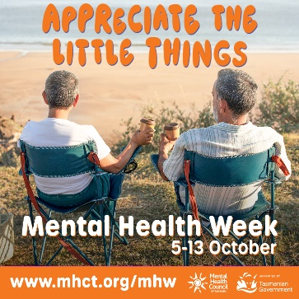

Figure 1: MHW Event in 2023

Figure 2: MHW promotional tile

## Suggested promotional content

You can share the following suggested posts with images, logos, etc. available from our [website](https://mhct.org/mentalhealthweek/resources/).

**Suggested social media post *in the lead-up* to Mental Health Week:**

*Mental Health Week in Tasmania this year will run from 5 – 13 October. The theme for Mental Health Week is ‘Appreciate the little things’.*

*The purpose of this awareness week is to engage communities in activities that promote mental health and wellbeing and also increase understanding and reduce stigma about mental illness, and how it impacts on the lives of people in our community.*

*Events and activities will be held across the state, and we want you to be part of it!*

*Learn more and get involved:* [*https://mhct.org/mentalhealthweek/*](https://mhct.org/mentalhealthweek/)

*#MentalHealthWeek2024 #MHW2024*

**Suggested social media post *for the week itself*:**

*It is Mental Health Week in Tasmania! Running from 5 – 13 October, and the theme for Mental Health Week is ‘Appreciate the little things’.*

*Events and activities will be held across the state, and we want you to be part of it!*

*Learn more and get involved:* [*https://mhct.org/mentalhealthweek/*](https://mhct.org/mentalhealthweek/)

*#MentalHealthWeek2024 #MHW2024*

**Suggested newsletter content:**

*Mental Health Week is part of a national mental health promotion campaign held in October each year, and incorporates World Mental Health Day, held globally on 10 October. The purpose of this awareness week is to engage communities in activities that promote mental health and wellbeing and also increase understanding and reduce stigma about mental illness, and how it impacts on the lives of people in our community.*

*Mental Health Week in Tasmania this year will run from* ***5 – 13 October****. The theme for Mental Health Week is****‘Appreciate the little things’****.*

*Events and activities will be held across the state, and we want you to be part of it!*

*Learn more and get involved:* [*https://mhct.org/mentalhealthweek/*](https://mhct.org/mentalhealthweek/)