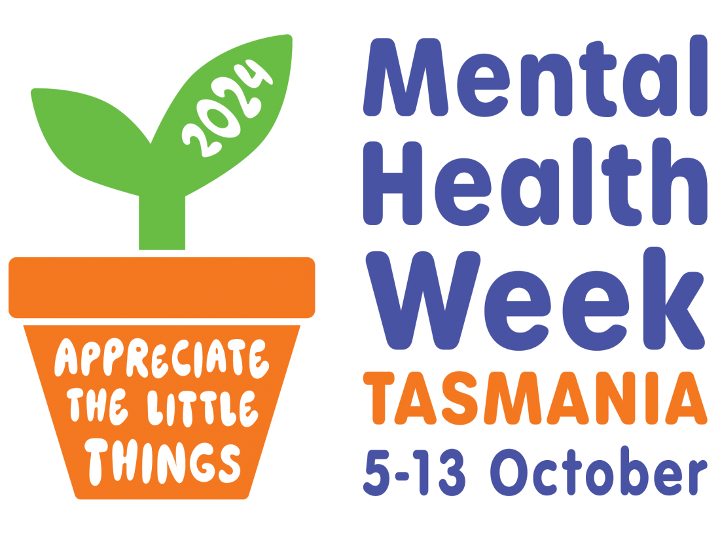
Event Promotion and Media Kit

Contents
MHW logos and their use 3
Protective factors and personal stories 5
Media tips and templates 7
Media Release example templates 8
Help-seeking and helplines 10
When in doubt… 11

Mental Health Week logos and their use
If your organisation is planning to create digital posters, fliers, or other marketing collateral for Mental Health Week, please utilise the 2024 Mental Health Week logo. There is both a version that includes the theme ‘Appreciate the little things’ and a more general MHW logo. In addition, we will be developing free, downloadable posters and associated marketing materials.

Visit the MHW Resources page to download logos, icons and posters (available mid-late June). Contact MHCT if you have any questions on 03 6224 9222 or enquiries@mhct.org

When using the logos, we ask that you do so in an unaltered format that is not distorted/skewed or framed in any way. If you would like assistance on this, please get in touch with us at the Mental Health Council of Tasmania 03 6224 9222. Also, just a reminder that if you increase the size of the logos significantly, it may risk distorting the image quality and resolution. There are several versions available to suit your individual design and printing requirements.

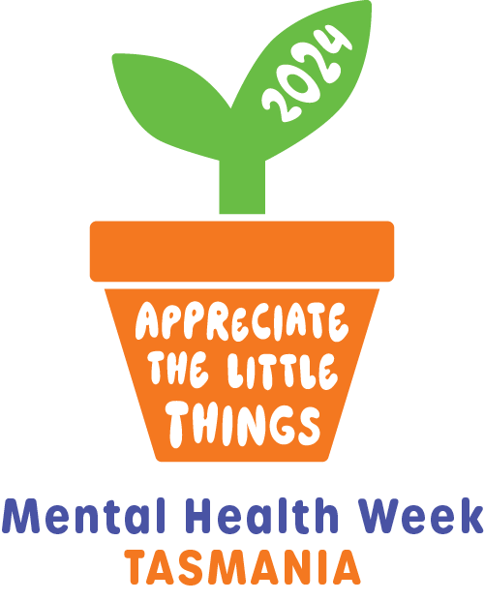

If you are a Mental Health Week grant recipient you will be required to display the MHW logo, the Mental Health Council of Tasmania Logo and the Tasmanian Government logo as displayed below.
Information on how to utilise the Mental Health Council is available through our Logo guidelines here. Downloadable versions of the MHCT logo and Tas Govt. logo are also available via the MHW Resources page

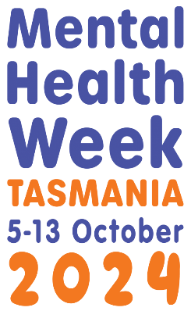

If you would like to use the colour scheme in your promotional materials, please use the following:

ORANGE (Main Colour)

R: 244 C: 0 #f47820
G: 120 M: 65
B: 32 Y: 100
K: 0

GREEN

R: 106 C: 63 #6abd45
G: 189 M: 0
B: 69 Y: 100
K: 0

BLUE

R: 75 C: 82 #4b53a4
G: 83 M: 77
B: 164 Y: 0
K: 0

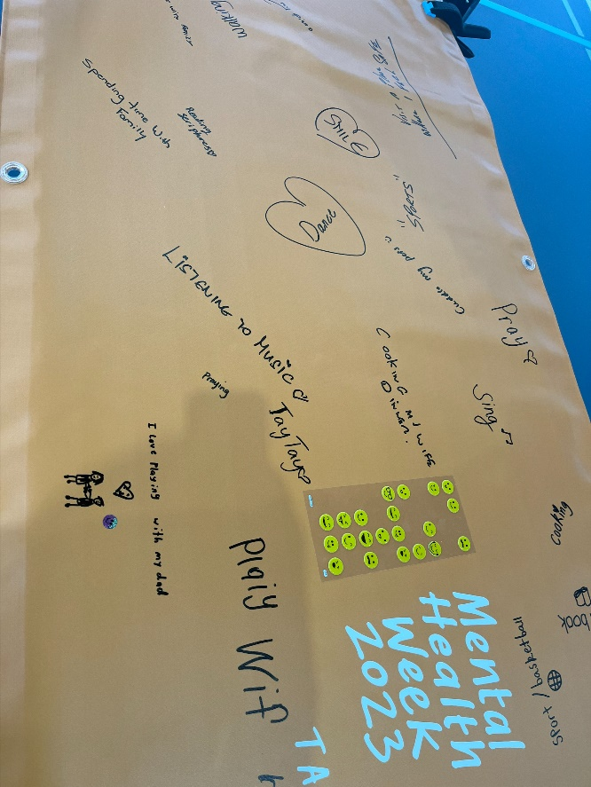

Protective factors and personal stories
If you are planning on arranging some interviews with media or planning to have a guest speaker or presentation you will need to think about supporting that speaker or interviewee throughout the process. Sharing personal stories about mental health and related issues can be daunting and the outcomes can be unexpected, particularly If that person isn’t prepared for the types of questions they might get or the impact sharing that story may have on their mental health. Even the most confident of speakers can find this unexpectedly challenging.

Sign the National Communications Charter
The National communications charter (the Charter) is an evidence-informed document to help guide the way mental health and suicide prevention sectors, governments, businesses, communities and individuals communicate about mental health and wellbeing, mental health concerns and suicide.
The Charter guides a united approach to the way we communicate about mental health concerns and suicide. Through a shared commitment and combined actions, we can work together to reduce stigma and discrimination, and communicate in ways that are safe, inclusive and hopeful.
Signing the Charter serves as a formal commitment to use safe and consistent communication about mental health and wellbeing, mental health concerns and suicide. It is an agreement to put the guiding seven principles into practice to reduce stigma, minimise harm and promote help-seeking and help offering.
Learn more at: https://lifeinmind.org.au/the-charter
Here are some more tips to try and avoid some negative experiences:
- Arrange a briefing session with any presenter or person sharing their story. This will be a chance to go over your expectations, their expectations and, where relevant, the expectations of the journalist conducting the interview
- Offer a de-brief session afterwards to go over how they think everything went, how they feel afterwards and what might they need to do to consider proactive ways to nurture their mental health after sharing their story
- Provide contact to professional services if that person is not already engaged with a support service. In some cases, it would be preferable for a professional to assist with the briefing and debriefing sessions. Ask the individual what would work best for them.
- Most importantly, if challenging or inappropriate questions are raised, reassure the individual during the pre-briefing that it is ok to say no to answering a question or outlining to the journalist what topics are off limits.
- Always ask permission before taking photos, video or posting someone’s image to social media. If you are working with people who are under 18, you will need parental or guardian consent to post or display images/video of children. MHCT can provide you with a consent form template
- Talk to the presenter or interviewee about the Mindframe guidelines for talking with media is a really great step to clarifying what is ok to talk about and what might be inappropriate or triggering for either the audience or the individual.

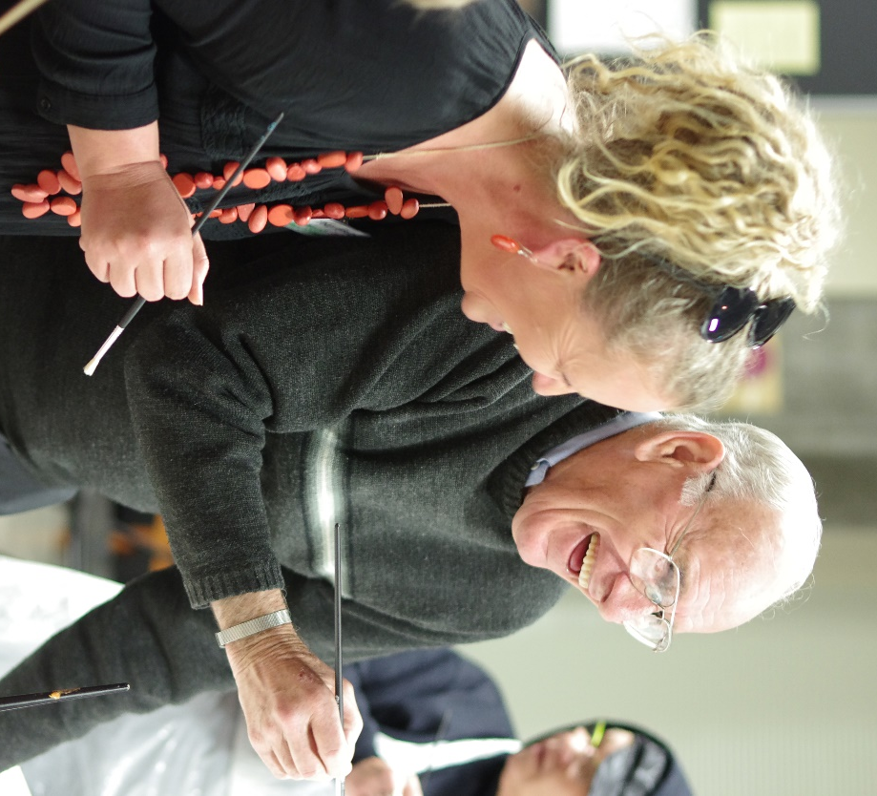

Media tips and templates
Journalists are people too
If your MHW event is open to the public, you may choose to engage with local media to promote the event, so you can build interest and attendance. You may also want to encourage media representatives to attend your event to raise awareness of mental health to a wide audience. It’s important to remember that journalists are just regular people, with various levels of mental health literacy. With that in mind it’s important to not only consider your audience, but how the media will communicate to that audience on your behalf.

Here are some tips in order to achieve those aims:

- Send your media release in the body of an email, NOT as an attachment. (This makes it more likely that your media release will be read, as people can be hesitant to open attachments from people they don’t know.)
- Keep your media short and sharp
- Try not to provide media with complex or detailed information. Just the basic Who, Where, When and most importantly WHY
- Provide photo or filming opportunities on your media release with specific times for media to arrive
- Provide a key spokesperson to speak to media before your event, during the event and after completion. Make sure they are available to answer the phone number provided
- Refer to Mindframe guidelines when speaking to media about mental health issues or suicide and suicide prevention
- Use the media release template provided as a guide to assist you if you are unfamiliar with producing media releases – see the examples on the next page.
If you plan to write and send out a media release to help promote your event, Nick at MHCT can provide a list of contact emails for journalists across the state nsullivan@mhct.org

 | MEDIA RELEASE  [Today’s date]  [INSERT HEADLINE (SEVEN WORDS OR LESS)]  [DATE | LOCATION | TIME OF EVENT] | INSERT YOUR LOGO HERE
[Insert a one or two line summary of your own event that is catchy and engaging].

[Insert event name] will be one of a wide variety of events held around Tasmania, as part of Mental Health Week from the 5-13 October 2024.

Mental health issues affect more than one in five Australians every year, so it is important to encourage Tasmanians to stop and think about their mental wellbeing. Mental Health Week creates an opportunity for people to think about the ways in which we can enhance our social and emotional wellbeing by building our personal resilience and support networks.

The 2024 theme, ‘Appreciate the little things’, aims to encourage everyone to support each other to look after and maintain their own mental health as they would their physical health. [Insert a sentence about how your event reflects the theme ‘Appreciate the little things’.]

[Name, position] said, “[Insert a 1-4 line quote about the event or the theme: consider why the event is being held, what they hope to see come out of the event or some points of interest for the day]”

[Insert some information about attendance – whether the event is public, whether media should organise attendance etc.]

- ENDS -
[Include information about when media contacts will be available for interview].
Available for interview:
[Name], [Position] – [Contact Number]

Please also include the following crisis support services for any story regarding mental health or suicide.
Lifeline: 13 11 14 www.lifeline.org.au , Suicide Call Back Service: 1300 659 467 www.suicidecallbackservice.org.au
beyondblue: 1300 22 4636 www.beyondblue.org.au
More information on safely reporting on mental illness or suicide can be found at
https://mindframe.org.au/ and https://www.tascharter.org/

Media Release example templates
(Please note that the examples below are in table format. This can make it easier to maintain formatting when cutting/pasting into the body of an email.)
 | MEDIA RELEASE  7 October 2024  ‘LAUGHTER IS THE BEST MEDICINE’ COMEDY FESTIVAL  13 OCTOBER 2024 | TOWN HALL | 7PM – 10PM | INSERT YOUR LOGO HERE
Laughter Tasmania will be holding a comedy festival as part of the 2024 Mental Health Week (MHW) events in Tasmania. A number of local comedians will perform free for the public throughout the evening. The comedy festival will be one of a wide variety of events held around Tasmania, as part of Mental Health Week, 5-13 October 2024.

One in five Australians will experience mental ill health every year, so it is important to encourage Tasmanians to stop and think about their mental health and seek and celebrate their wellbeing. This year in particular, we’ve all had some challenges to face, and it can be tough to stay mentally healthy. MHW provides an opportunity for Tasmanians to think about the importance of mental health and wellbeing, and the connections

The 2024 MHW theme is ‘Appreciate the little things’. As part of the evening we will be inviting the audience to show their support by …

Joe Bloggs, local comedian, said, “My own mental health has been something that I’ve struggled with, so the opportunity to get other people thinking about looking after themselves is something I’m really looking forward to.”

The event will be open to the public, and Laughter Tasmania would like to invite all residents to attend. They would also like to remind people that if you need to seek supports or find services in Tasmania go to www.checkin.org.au
Organisers and comedians will be available for interview on the (insert venue and timing). All media representatives are invited to attend the event.
-ENDS-
Available for interview:
Joe Bloggs, comedian – (insert phone number and email)
Jane Bloggs , Laughter Tasmania Publicity Officer – (insert phone number and email)

Please also include the following crisis support services for any story regarding mental health or suicide.
Lifeline: 13 11 14 www.lifeline.org.au , Suicide Call Back Service: 1300 659 467 www.suicidecallbackservice.org.au ,beyondblue: 1300 22 4636 www.beyondblue.org.au

More information on safely reporting on mental illness or suicide can be found at
https://mindframe.org.au/ and https://www.tascharter.org/

Help-seeking and helplines
In any story you do with media or anything you do publicly for Mental Health Week it is important to encourage help-seeking behaviour. Whilst we are encouraging everyone to look after their own mental health and support each other, we need to remember that so many of us do not seek help when we are struggling.
It’s important to include relevant helplines and websites where applicable to start people on the right track when seeking help. Here is a comprehensive list of helplines. The recommendation is to include at least two for every story, the default tends to be only including Lifeline, but this is considered insufficient, particularly when there are so many helplines available for different groups and demographics:
Lifeline: 13 11 14
www.lifeline.org.au
beyondblue: 1300 22 4636
www.beyondblue.org.au
SANE Australia helpline
1800 18 SANE (7263) or www.sane.org
Suicide Call Back Service:
1300 659 467
www.suicidecallbackservice.org.au
For men of all ages nationally
MensLine Australia: 1300 78 99 78
www.mensline.org.au
Youth Support Services
Kids Helpline: 1800 55 1800 (27/7 crisis support)
www.kidshelp.com.au
headspace: 1800 650 890
www.headspace.org.au (direct clinical services)
ReachOut.com
www.reachout.com
Veterans Support Service
Veterans and Veterans Families Counselling Service
1800 011 046
www.vvcs.gov.au
Eating Disorder Support
Butterfly Foundation Support Line
1800 33 4673 or www.butterflyfoundation.org.au
LGBTI Specific Support
MindOUT
www.lgbthealth.org.au/mindout
QLife line: 1800 184 527
www.qlife.org.au
Also consider promoting Check In – our campaign to promote checking in with your own mental health and supporting others. Services and supports tailored to Tasmanians can be found at: www.checkin.org.au

When in doubt…

Ask for help if you aren’t sure that you’re addressing issues appropriately. Mental health is a complicated area to publicise.
Seek the expertise of those who know about these topics. Do your research, if you can arm yourself with even a little knowledge it will go a long way. You may get asked some curly or confronting questions if hosting a mental health week event. If you aren’t a professional working in the mental health sector, consider engaging someone who is to attend your event.
Don’t hesitate to get in touch if you have any questions or concerns around media coverage or any of the other topics contained in this document: Nick Sullivan nsullivan@mhct.org or 6224 9222.

