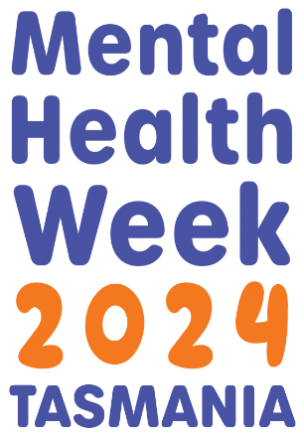
Event Planning Guide
How to run an engaging and successful event or activity during Mental Health Week

Mental Health Week in Tasmania is coordinated by the Mental Health Council of Tasmania

Contents
Background 3
What is Mental Health Week in Tasmania? 3
Mental Health Week theme for 2024 3
Planning a great Mental Health Week event 4
Mental Health Week event ideas 6
Promoting your Mental Health Week event 8
Mental Health Week Event Planning Checklist 8
The big day! 9

Background
The Mental Health Council of Tasmania is the coordinating organisation of Mental Health Week in 2024, which is supported by the Tasmanian Department of Health

Mental Health Week in Tasmania will take place 5 – 13 October 2024.

This Guide will provide you with tools and resources designed to help make your event a great success and an acknowledged part of state-wide awareness week activities. You’ll find specific guidelines about the Mental Health Week theme, as well as ideas to support safe and engaging communication about Mental Health Week and mental health more broadly, together with event promotion, planning and evaluation tips.

What is Mental Health Week in Tasmania?
Mental Health Week in Tasmania is part of a national mental health promotion campaign held in October each year, and incorporates World Mental Health Day, held globally on 10 October. The purpose of this awareness week is to engage communities in activities that promote mental health and wellbeing, and to raise awareness and understanding about mental illness, and how we can better support people in our community.

Mental Health Week theme for 2024
The Mental Health Week theme for 2024 is ‘Appreciate the little things.’ The 2024 Mental Health Week logo will be available for download from www.mhct.org/mentalhealthweek in the lead up to Mental Health Week, which will help your group or organisation promote events in your community.

The theme provides an inclusive and overarching message to help guide your event planning:
Sharing a smile with a stranger, spending time in the garden, hearing your favourite song on the radio…

What are the things that give you a glimmer of calm and peace on a busy day? The small moments that wouldn’t make the news, but make you feel good?

Having coffee with an old friend, watching a breathtaking sunset, listening to birds singing in the trees…

This Mental Health Week, take a minute to appreciate the little things.

Planning a great Mental Health Week event
Think about the goals of your event
During the planning phase, it is important to consider why your group or organisation is hosting a Mental Health Week event. Ask yourself, will my event:
- raise awareness and promote positive mental health and wellbeing
- reduce stigma
- build resilience and foster understanding
- promote the Mental Health Week theme ‘Appreciate the little things’
- build partnerships and connections within the local community
- encourage individuals to seek help when they may need it
- encourage self-care, and promote resources such as www.takeaminute.com.au

Know your audience
When hosting a Mental Health Week event, it is important to think about who you are communicating with. You may choose to involve a specific group. Once you know who it is you are communicating with, give some thought to the following questions:
- What is the audience’s level of mental health literacy? What will they already know about mental health, and will I need to consider their knowledge and understanding for what I want to achieve?
- Who are they? Demographics, gender, culturally and linguistically diverse etc. These factors might contribute to your communication methods. For example, the way you deliver an event for young people and what you talk about may be very different from an event targeting older Tasmanians.
- Consider what might be confronting or ‘triggering’ for this audience. If the audience is the general public, and you might be discussing things that people could find distressing, a warning is necessary as well as access to appropriate supports.

Agree on your key message
What is the main message/s you want your audience to take away from your event or activity? For example, your event may promote great self-care ideas, stigma reduction in communities, or ways to seek help. Make sure you convey the key message in all your promotions.

Know your topic
Here are some general tips around talking about mental health or mental illness:
- Avoid jargon or complex descriptions of mental health conditions
- Always talk about mental health in a way that focuses on prevention, mental health promotion and, wherever possible, early intervention.
- Try not to describe illness or mental ill health as someone having ‘mental health’. Instead try:
- they have a lived experience of mental illness
- they have a diagnosed mental health condition (if this is confirmed)
- they have experienced mental ill-health
- they have experienced/are experiencing mental health issues
- avoid saying someone ‘suffers’ from a mental illness or is ‘mentally ill’
- avoid the term ‘mental patient’. Please use the term patient (in a hospital situation) with a mental illness (if this is accurate and confirmed)

For more information on communicating safely and effectively about mental health and suicide prevention please visit the Mindframe Guidelines.

Consider Grants, sponsorships, partnerships, and volunteers
Make time to do a scan for what is possibly available for grant, funding support or sponsorship opportunities from organisations, funding bodies, local councils, or other groups or businesses. Think of it as a way to share resources and increase your ability to have an impact. Check out the eligibility and selection criteria on our website, then consider applying for the Mental Health Week Small Grants Program as an option.

Register your Mental Health Week event
By registering your Mental Health Week event your activity will be an official Mental Health Week event in Tasmania and enable us to help you spread the word via our social media community. To register, simply fill in the event details. Contact MHCT if you have any questions on 03 6224 9222 or enquiries@mhct.org

Mental Health Week event ideas
Mental Health Week provides the opportunity for communities to come together. The best events encourage participants and local communities to engage in practical and interactive activities to improve their mental health. If you have a great idea but are uncertain of how to get started, give us a call and we can chat through your ideas and provide some guidance (6224 9222). This year we want to encourage people to branch out and look at holding an event that is open to the general public and widely promoted. Do seek out collaborations and partnerships with other organisations to maximise impact.

The theme this year is ‘Appreciate the little things.’

To help get you thinking about your own event, here are some examples of events that promote ‘Appreciate the little things’:

- There is more and more research into the links between mental health, nutrition, and exercise. Organise a wellness walk, cycle, swim, run, yoga or meditation session.
- The benefits of engaging in something creative for your mental health is well documented. Organise workshops in painting, pottery or creative writing in your local area. Hold a photography competition that explores the ideas of the Mental Health Week theme. It’s a great idea to look at activities that will having a lasting impact on participants.
- Hold a self-care session that looks at the ideas of mindfulness or music therapy, or bring people together around music and voice
- Have a ‘Dress in Orange’ day, or pop an orange light globe in your shop front or office. We’ve chosen orange as the official colour for Mental Health Week in Tasmania because it is warm, and inviting, and has a positive and uplifting influence.
- Develop a community forum with a panel of guest speakers to consider questions about mental health, wellbeing and stigma reduction in your community from the audience.
- There may be community groups, your local council or neighbourhood house that already have great initiatives that could be held or promoted during Mental Health Week. Start the conversation now.
- Music or comedy performances are excellent ways to get people talking or thinking about difficult issues. Why not hold a concert or comedy gig? Just make sure it has some link to Mental Health Week and the theme.
- Hold a neighbourhood Mental Health Week celebration. Encourage different generations to socialise together.
- Have a getting to know a neighbour ‘speed’ find a mate (rather than a ‘speed date’) event.
- Set up a ‘have a chat’ bench in your local area similar to the concept of a buddy bench you might see in primary schools.
- Check in with other community organisations and events and see how you can partner up to promote mental health and wellbeing.

The ideas are endless and remember creativity will be rewarded if you are applying for a grant. It will be school holidays in Tasmania this year during Mental Health Week. So, it is worth bearing in mind that schools will be able to celebrate on a date adjacent to Mental Health Week in order to hold their own events. Working all week? Consider having an event at your workplace and get the whole team involved.
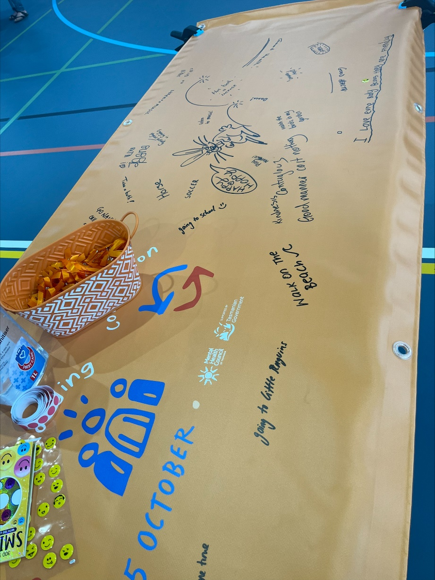
Mental Health Week themed banner for 2023, with positive activities from members of the public.

Promoting your Mental Health Week event
Effective promotion will ensure your Mental Health Week event is successful. Consider using the right tools at the right time to maximise participation. Don’t hold back! Promote your Mental Health Week event far and wide. Mental Health Week events are a great opportunity for the media to bring attention to mental health and assist in the reduction of stigma.

Effective ways to promote your Mental Health Week event include:
- Utilise your networks. Consider asking schools to include your Mental Health Week event information in their newsletter. Ask shops, councils, community organisations and businesses to support your Mental Health Week activity, put up your poster or have flyers on display to help spread the word.
- Use social media. Register your Mental Health Week event on the Mental Health Week registration webpage, and we’ll help you promote it through our social media channels and newsletters. You should use your own social media channels too!
- Contact local media. Chat to the local newspaper, radio station or local TV station to elicit their support to promote your event.
- Write a media release. The easiest method to get the attention of media.
- Send personal invitations. Target VIPs or specific people and invite them to participate or speak at your event and utilise their networks to build engagement and participation.
- Sharing is caring. Consider asking friends and colleagues to help you share organically, person-to-person. Forwarding e-invitations, emails or sharing social media posts is an easy and effective way to spread the word about your Mental Health Week event.
- Consider advertising. At your place of work, local library or community hall, cafes and shops.
- Use the Mental Health Week logo and the colour orange – we’ve chosen orange as the official colour for Mental Health Week in Tasmania, because it is warm, and inviting, and has a positive and uplifting influence.

Mental Health Week Event Planning Checklist

We have a handy Event Planning Checklist available on our website, here. It’s fairly comprehensive as it’s designed to cover events of all scales. If you’re only planning a small event, it’s likely that there will be a lot of things on the list that don’t apply to you, so don’t be overwhelmed. Even if you’re event is only small, there might be a few things on the checklist that could make your event even better that you hadn’t considered, so it’s a good starting point.

The big day!
Your event is registered on the Mental Health Week registration page, you have your media release ready to go, your social media community is engaged, now – for the big day!

Pre-event
- Provide your staff/team with a full event briefing, and encourage questions
- Provide a run sheet for the event, including timings and locations, and responsibilities, and contact names and numbers
- If you have volunteers, make sure you have a meeting point organised, and water and food
- Review your event checklist, emergency arrangements and other important logistics
- Pack your gear – event bag, promo items and hand-outs, water for staff, phone and charger, IT
- Bump in! Organise your transport and support team to help set up

Post-event
- Bump Out! Organise your transport and support team to help pack down
- Thank you letters to staff, volunteers, speakers, performers and special guests
- Engage and ask for feedback on social media
- Close off budget and acquit any funds
- Hold a de-brief with your team and encourage ideas and feedback on how the event can be improved next year
- Let us know how it went! Share some highlights from your event via social media and tag us in the post so we can share your success with our online community.

Stress Less Tips
Mental Health Week can be a time when people are prompted to find out more about their own mental health and seek help when needed. Following are some tips that you might find useful if someone approaches you for help when holding your event.

Be prepared
If you work in the mental health sector, you will have some experience in responding to enquiries about mental illness. Otherwise, consider asking a local health professional to assist and attend the event to be on hand to provide support and advice if necessary. Make sure you have a handout with details of helplines and appropriate services available. Check out MHCT’s ‘Getting Help’ webpage.

Know your boundaries
Before the event, give some thought to your boundaries. What are you confident and comfortable to talk about? What might you need more information or support with? When might you need to refer someone to another source of assistance? Remember, it is OK not to know everything.

Look after your team
Remember that looking after yourself and your team is just as important as looking after others. Keep the lines of communication open with your team on the Mental Health Week event day. Include a discussion about this element with your team in your pre-event briefing and post-event review.

