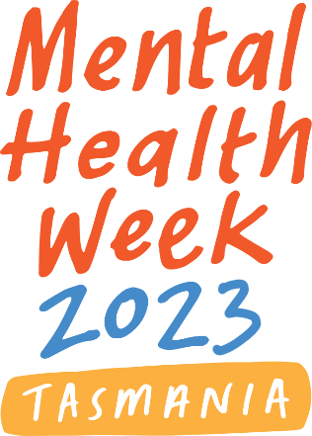
Social Media Kit
Get involved in promoting Mental Health Week

Mental Health Week in Tasmania is coordinated by the Mental Health Council of Tasmania

Background
The Mental Health Council of Tasmania is the coordinating organisation of Mental Health Week in 2023, which is supported by the Tasmanian Department of Health. The theme for Mental Health Week is ‘Awareness, Belonging, Connection’.
Mental Health Week in Tasmania will take place 7 – 15 October 2023.

What is Mental Health Week in Tasmania?
Mental Health Week is part of a national mental health promotion campaign held in October each year, and incorporates World Mental Health Day, held globally on 10 October. The purpose of this awareness week is to engage communities in activities that promote mental health and wellbeing and also increase understanding and reduce stigma about mental illness, and how it impacts on the lives of people in our community.

Launching Mental Health Week 2023
To launch Mental Health Week in Tasmania this year, MHCT will be travelling around the state to hear from the community about the little things they do to look after their mental health and wellbeing.
As part of the tour we will be setting up in Burnie, Hobart and Launceston with a large Mental Health Week banner, and inviting Tasmanians to write on it an activity they do that has a positive impact on their mental wellbeing.
This could be anything from going for a run, to taking a nice warm bath, to going to bed early and getting a good night’s sleep.
As we are only able to make it in person to a few locations, we have created resources for a DIY version of the activity so that schools, workplaces, clubs and other groups can join in and help us reach our target of 10,000 Tasmanians. These are available from the Mental Health Council website and include simple instructions on how to set it up.
1 Participants attending Break O’Day Council’s 'Festival of Wellbeing' in St Helens

How to show your support

Help us reach our launch goal of hearing from 10,000 Tasmanians!
Join in in-person during our launch tour. We’ll be in Hobart on 4th October, Burnie on 5th October, and Launceston on 6th October.
- Hobart, 4th October, 10am-12pm, Elizabeth Mall
- Burnie, 5th October, 10am-12pm, Marine Terrace Car Park Plaza
- Launceston, 6th October, 10am-12pm, Brisbane St Mall

…or run your own! Unfortunately, we can’t visit everywhere, so we know that not everyone will be able to make it in-person. That’s why we’ve created a version of the activity that you can run at your school, workplace, or club. Learn more and download the activity here.

Host your own MHW event. Register your MHW event or activity on our online program. We also have an Event Planning Kit to help you plan and run a successful activity.

Explore the events and activities happening during MHW and get involved. There are heaps of fun, family friendly events happening around the state. Check the program to find what’s happening near you.

Spread the word! You can download social media tiles, email banners, Zoom/Teams background and other resources on our website, here. We’ve also created some suggested social media and newsletter copy down below to go along with them, below.

Suggested promotional content
You can share the following suggested posts with images, logos, etc. available from our website.

Suggested social media post in the lead-up to Mental Health Week:
Mental Health Week in Tasmania this year will run from 7 – 15 October. The theme for Mental Health Week is ‘Awareness, Belonging, Connection’.
The purpose of this awareness week is to engage communities in activities that promote mental health and wellbeing and also increase understanding and reduce stigma about mental illness, and how it impacts on the lives of people in our community.
Events and activities will be held across the state, and we want you to be part of it!
Learn more and get involved: https://mhct.org/mentalhealthweek/
#MentalHealthWeek2023 #MHW2023

Suggested social media post for the week itself:
It is Mental Health Week in Tasmania! Running from 7 – 15 October, the theme for Mental Health Week is ‘Awareness, Belonging, Connection’.
Events and activities will be held across the state, and we want you to be part of it!
Learn more and get involved: https://mhct.org/mentalhealthweek/
#MentalHealthWeek2023 #MHW2023

Suggested newsletter content:
Mental Health Week is part of a national mental health promotion campaign held in October each year, and incorporates World Mental Health Day, held globally on 10 October. The purpose of this awareness week is to engage communities in activities that promote mental health and wellbeing and also increase understanding and reduce stigma about mental illness, and how it impacts on the lives of people in our community.
Mental Health Week in Tasmania this year will run from 7 – 15 October. The theme for Mental Health Week is ‘Awareness, Belonging, Connection’.
Events and activities will be held across the state, and we want you to be part of it!
Learn more and get involved: https://mhct.org/mentalhealthweek/

